Introduction to the Whitewater Rafting Website
Joyce Keil

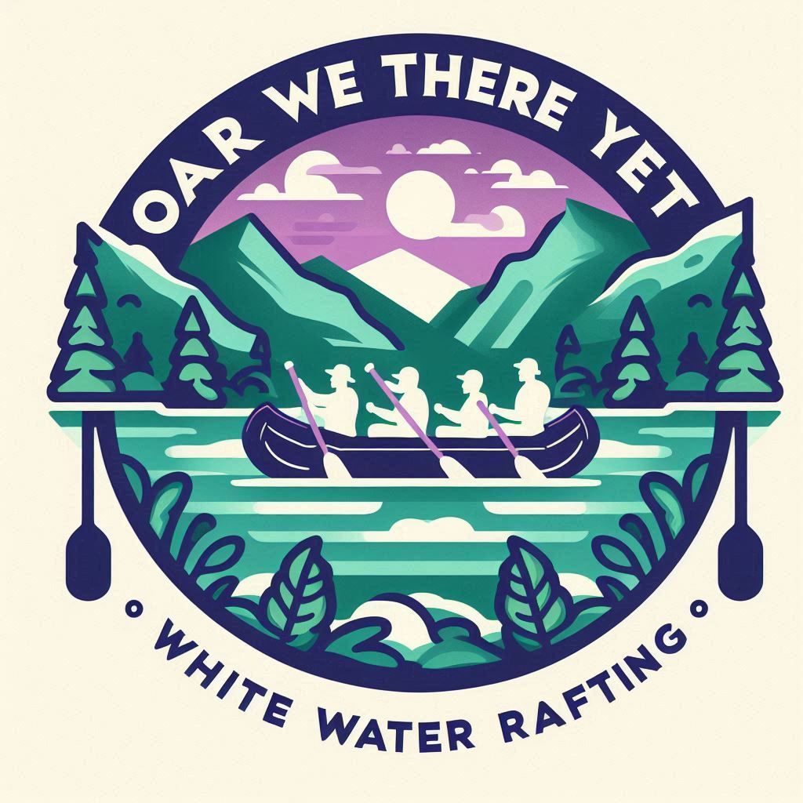

Primary-color: 373466
secondary-color: DFD6D6
ascent1-color: 1B5866
ascent2-color: AD70AD

heading-font: Delius Static
text-font: Sour Gummy

https://coolors.co/ad70ad-dfd6d6-1b5866-373466

